**TEST RESULTS**

**Oscillations in the VCE**

Since IGBT has some small parasitic capacitances, instant change of voltage causes some oscillations at the collector emitter voltage. These oscillations may make harm to the IGBT because it has some limited ratings like max surge current and max surge voltage and oscillation may cause exceeding those limits in a short amount of time. Even it does not destroy the component, it can surely shorten the lifetime of the component. Since we are not supposed to make an industrial product which can work like four year in a row, we did not consider the shortening lifetime, but for the safety of the component. The oscillations are observer by oscilloscope.

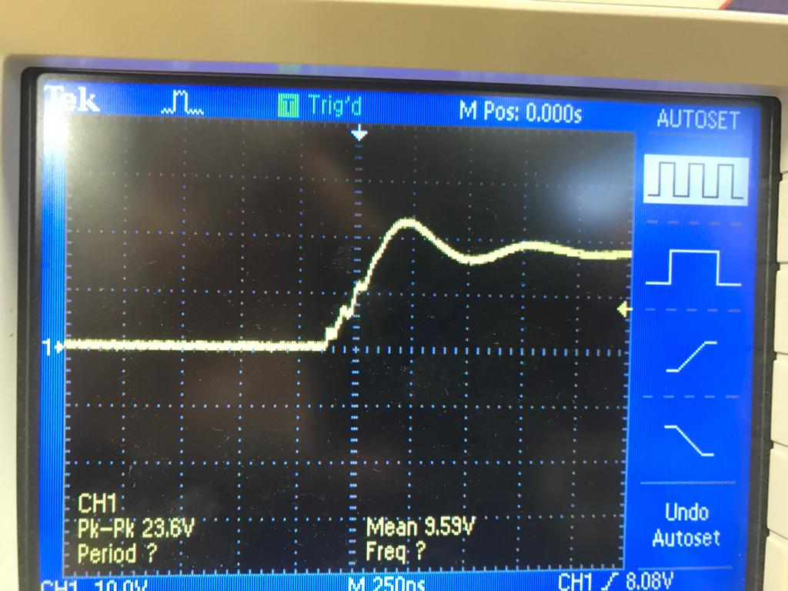

Figure ??: oscillations of the VCE voltage.

As can be seen from the figure we could not get the measurement of the frequency however, we can determine it from the figure because we know how much time elapses between the divisions in the screen

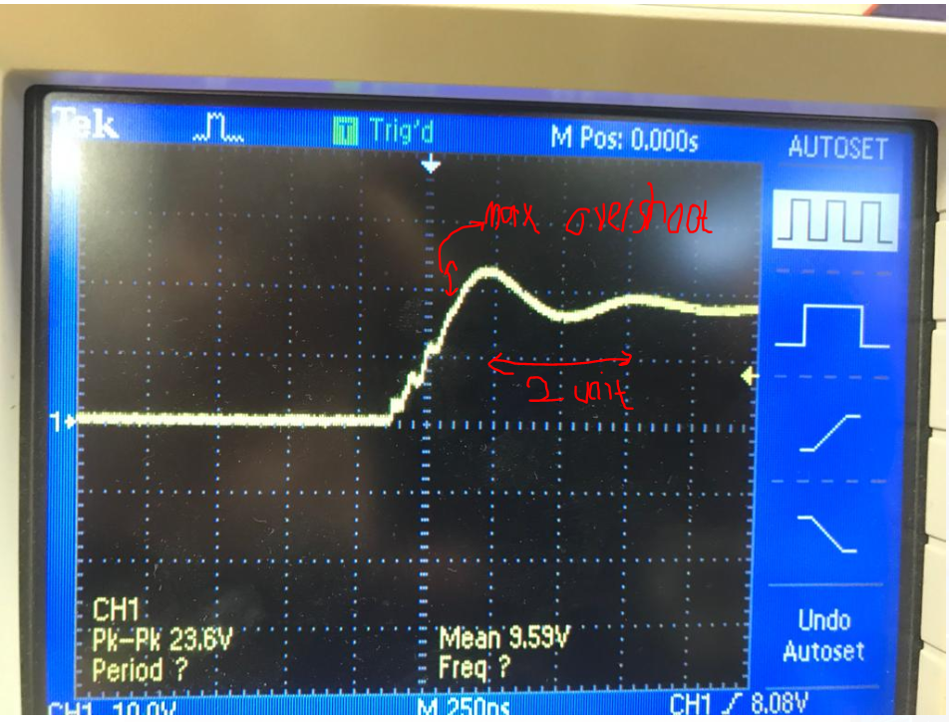

Figure??: Calculation of the frequency and overshoot.

* Since there are 2 division for one cycle of the signal

2= T=0.5e-6 ( period is found as 0.5 usec) and it corresponds to 2 MHz.

* And maximum overshoot roughly %20 from the above figure and this will not be threat for the IGBT because maximum of ideal VCE is about 200V and with the overshoot it becomes 240V which is still far from the 600 V rating of our IGBT. Therefore, snubber circuit for damping the these oscillations are not considered.